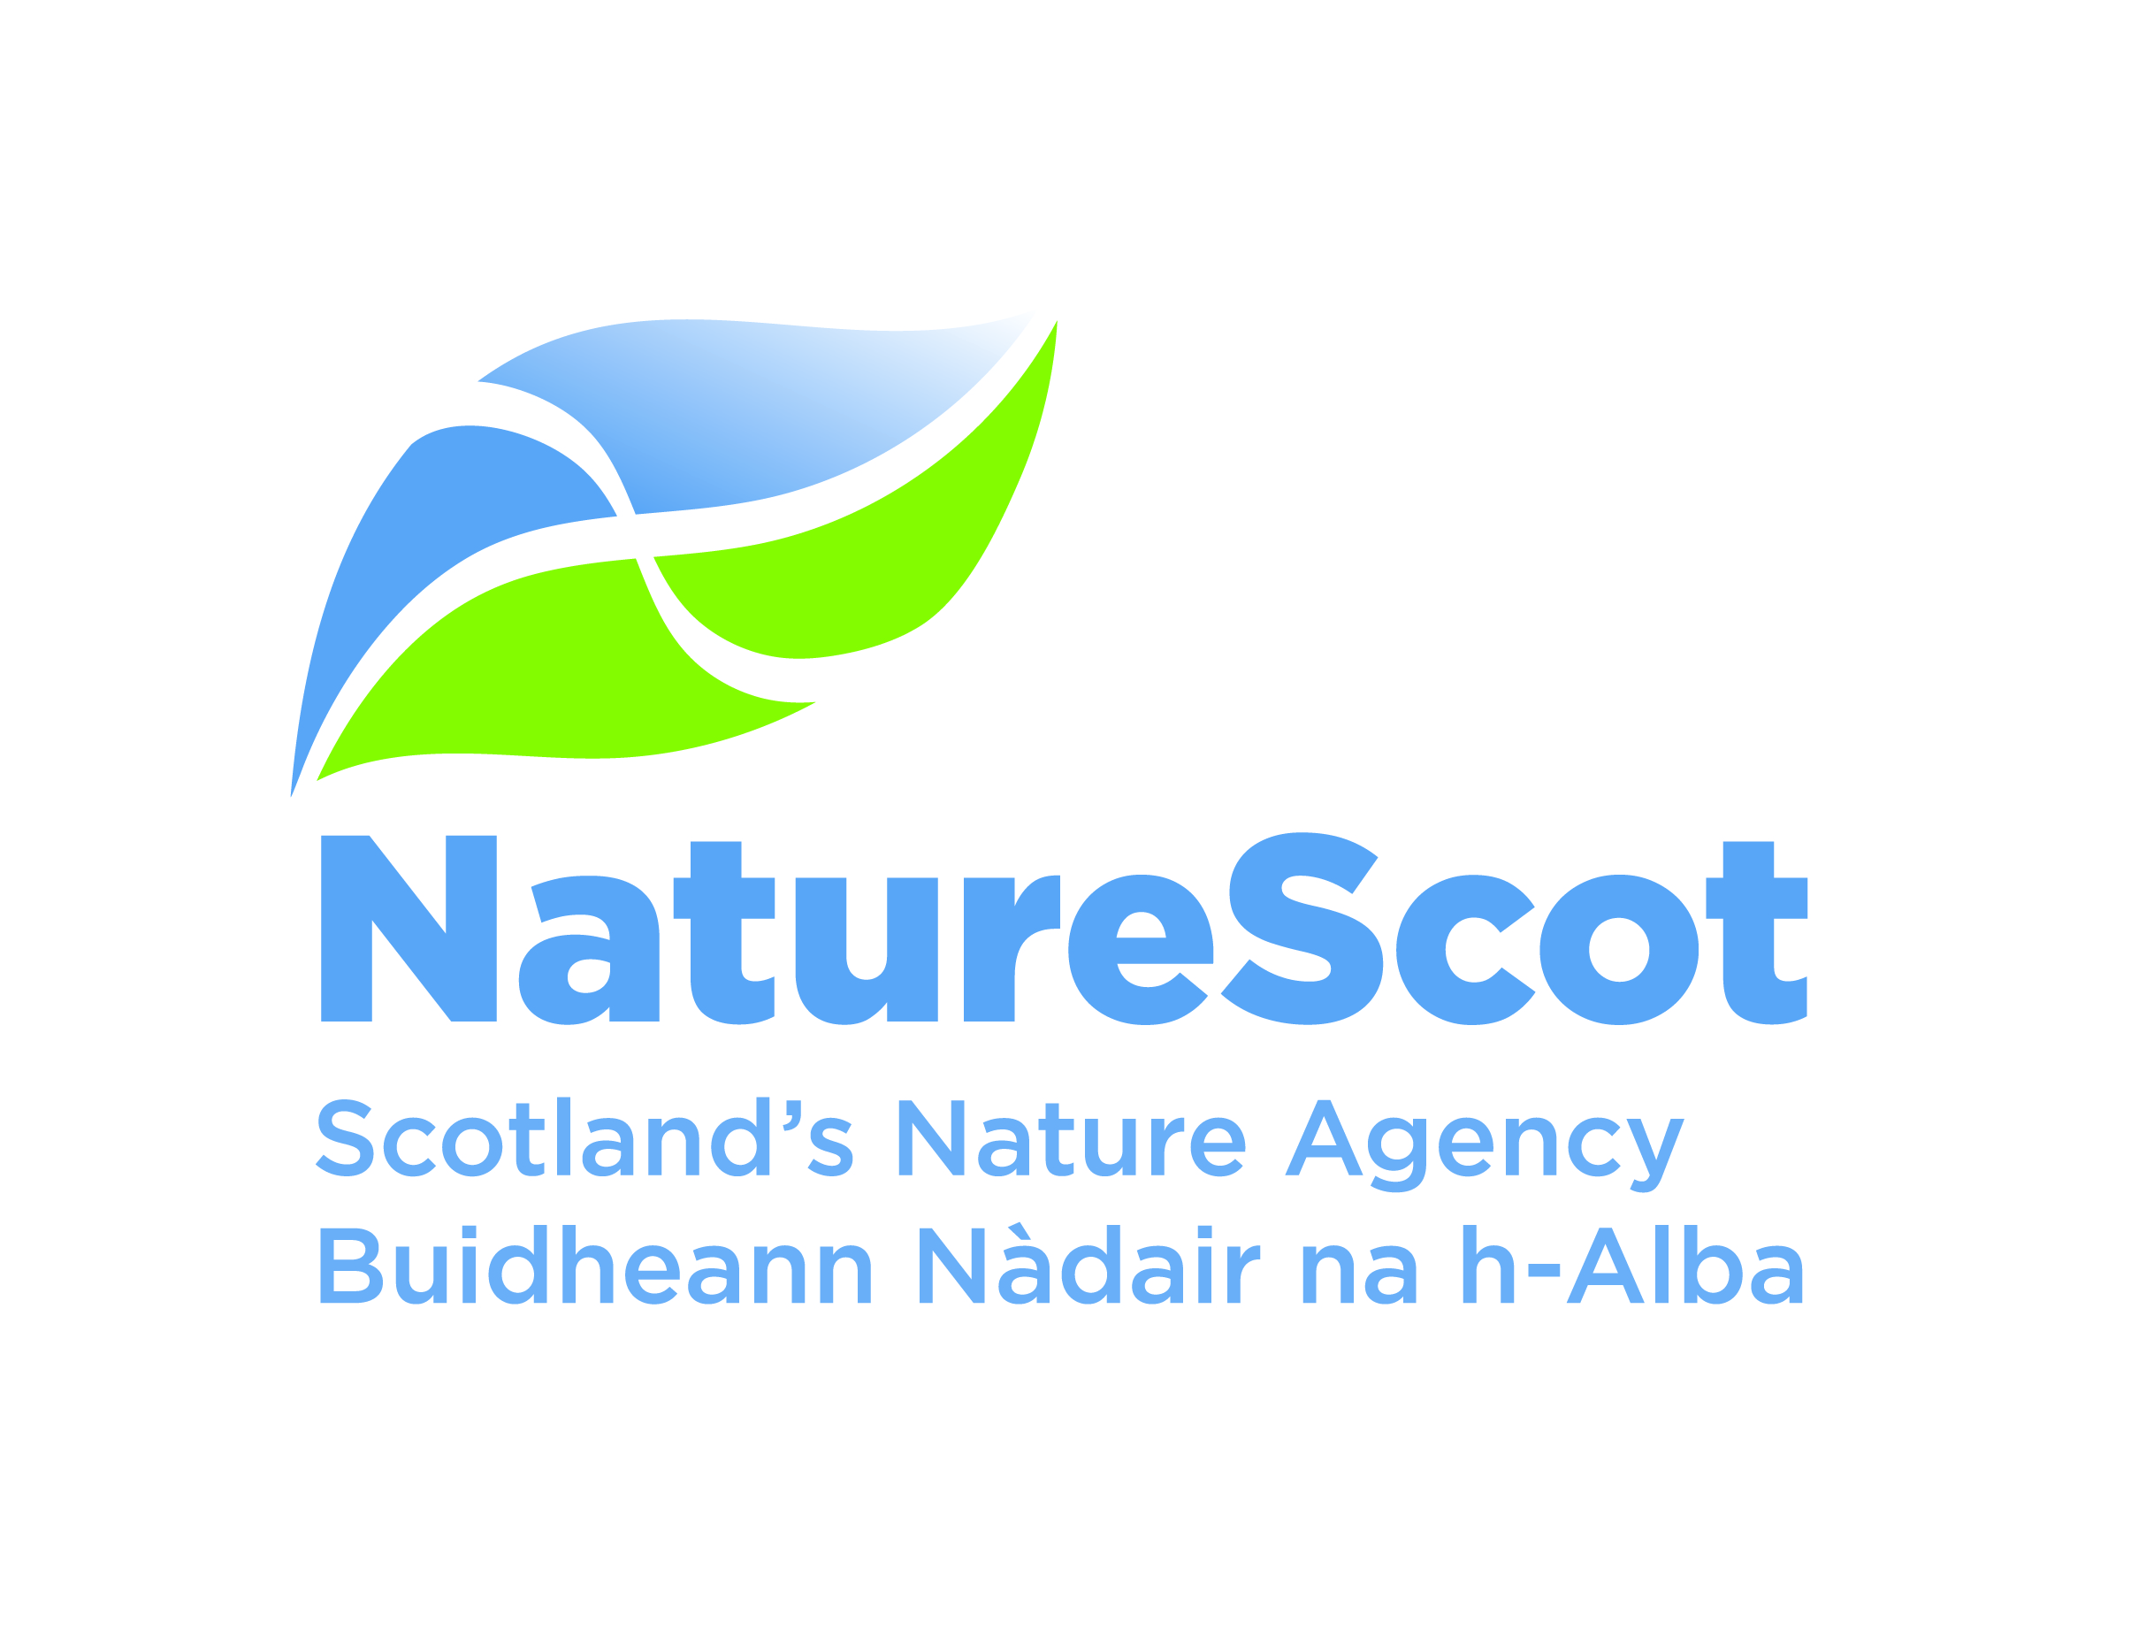 PRIVATE AND CONFIDENTIAL
Volunteer Expression of Interest Form

We would appreciate your co-operation in completing this form. This will enable us to match potential volunteers to the most appropriate tasks, and, to maintain a record of possible volunteers. The information you give will be treated with the strictest confidence.

Please complete this form in black ink, as it may be photocopied or scanned.
Name:

Address:

Postcode:

Age (if under 18*):

Sex (at birth):

Telephone:

Email:
* Please note there are no opportunities for under age 16 to volunteer due to Health and Safety and Child Protection legislation. Our residential volunteering placements are not available to people under age 18.

Eligibility to Volunteer in the UK
If you are a British citizen as defined here the check if you're a British citizen on the GOV.UK website you will be eligible to volunteer with us. If you are not a British citizen please provide information about your visa status to be in the UK as it will need to include volunteering. Please note that, if we are minded to offer you a volunteer placement, we will ask to see a copy of your visa in advance of offering you a placement. Please note these important points 1) we do not offer sponsorship for a volunteering visa and 2) we are not a charity so if the visa only covers volunteering for a charity that won’t be possible with NatureScot.
I am a British citizen Yes / No (delete as appropriate)

If No please give details below of your visa status to be in the UK including the detail that it gives about volunteering eligibility

Are you responding to an advertised volunteer opportunity?
If yes please give the title and location of the Volunteer Role you are interested in.
If no please provide information about what type of volunteering role are you interested in eg habitats and species; working with people; working on a National Nature Reserve; practical work; working in a visitor centre or office etc?

What duties are you particularly interested in?

Is there a particular location where you would like to volunteer? If you are interested in a residential volunteering placement at either Beinn Eighe or Creag Meagaidh NNR please state clearly which one is your first choice and which is your second choice. If you are applying for a residential volunteering placement please note we have same-sex accommodation. We will allocate your accommodation according to your sex (at birth).

How did you find out about volunteering with NatureScot?

What experience and skills you can offer?
(Please tell us about previous relevant experience. Educational and professional qualifications are not necessary. Continue on a separate sheet if necessary. You may enclose a copy of your CV if you wish.)

Do you hold a current UK driving licence? Yes / No
What dates do you hope to do this – roughly? eg November 2025 or any time during summer 2026. Feel free to give precise dates if you have no flexibility with your availability.

What days and times are most suitable for you eg weekdays / weekends / residential etc

Please add any other information that might be helpful eg why do you want to volunteer

Name and address of 2 referees (either from your last employment or a member of the community
who can provide a character reference, not a close relative). We will let you know if we intend to seek a reference.

1.

2.

NatureScot is committed to ensuring that all reasonable steps are taken to provide for the Health and Safety of our volunteers. Volunteers are also responsible for their health and safety. Please provide details below of any condition(s) that may restrict the range of tasks that you can undertake (we also require that volunteers who do receive a Volunteer Placement complete a Health Declaration form before starting):

Thank you for completing this form, and offering your time and skills to support the care and improvement of Scotland’s natural heritage. We hope we are able to offer volunteering opportunities that meet your interests and needs. However, if we are unable to offer anything there are many other organisations that you could ask. Learn more at the volunteering useful organisations and contacts list on our website.

If you are applying for a particular advertised volunteer role please email or post this form to the person named in the advert for that role.

If you are applying speculatively please email it to volunteer@nature.scot or post it to Alison Matheson, NatureScot, Great Glen House, Leachkin Road, Inverness, IV3 8NW.

Form updated 30 April 2025

